# CS 255 System Design Document

# Rico Applewhite

## UML Diagrams

### UML Use Case Diagram

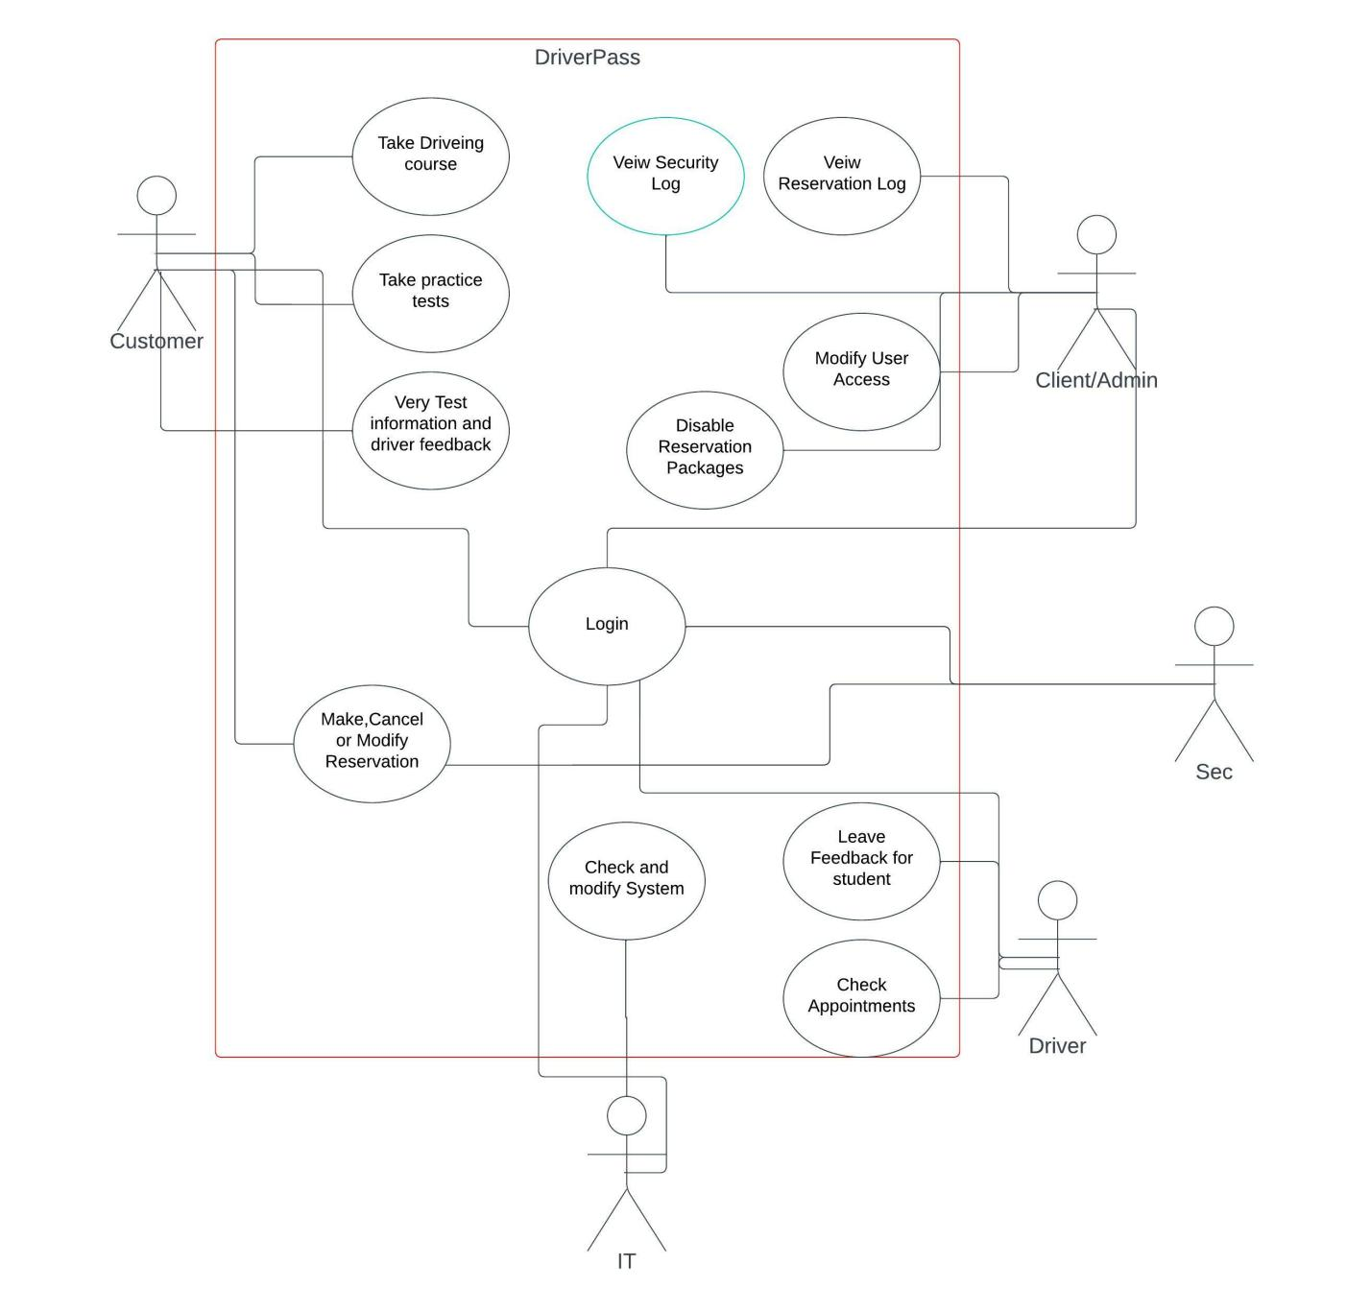

### UML Activity Diagrams

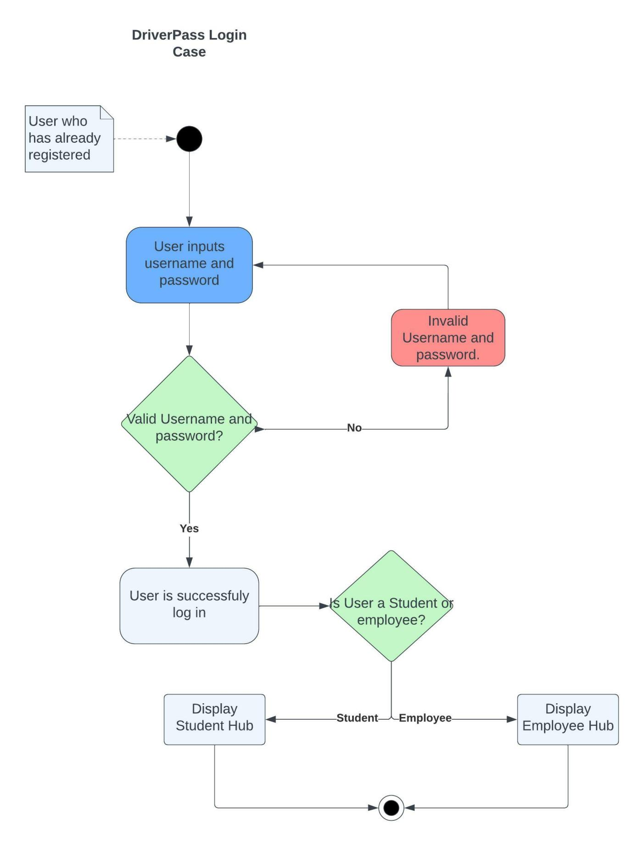

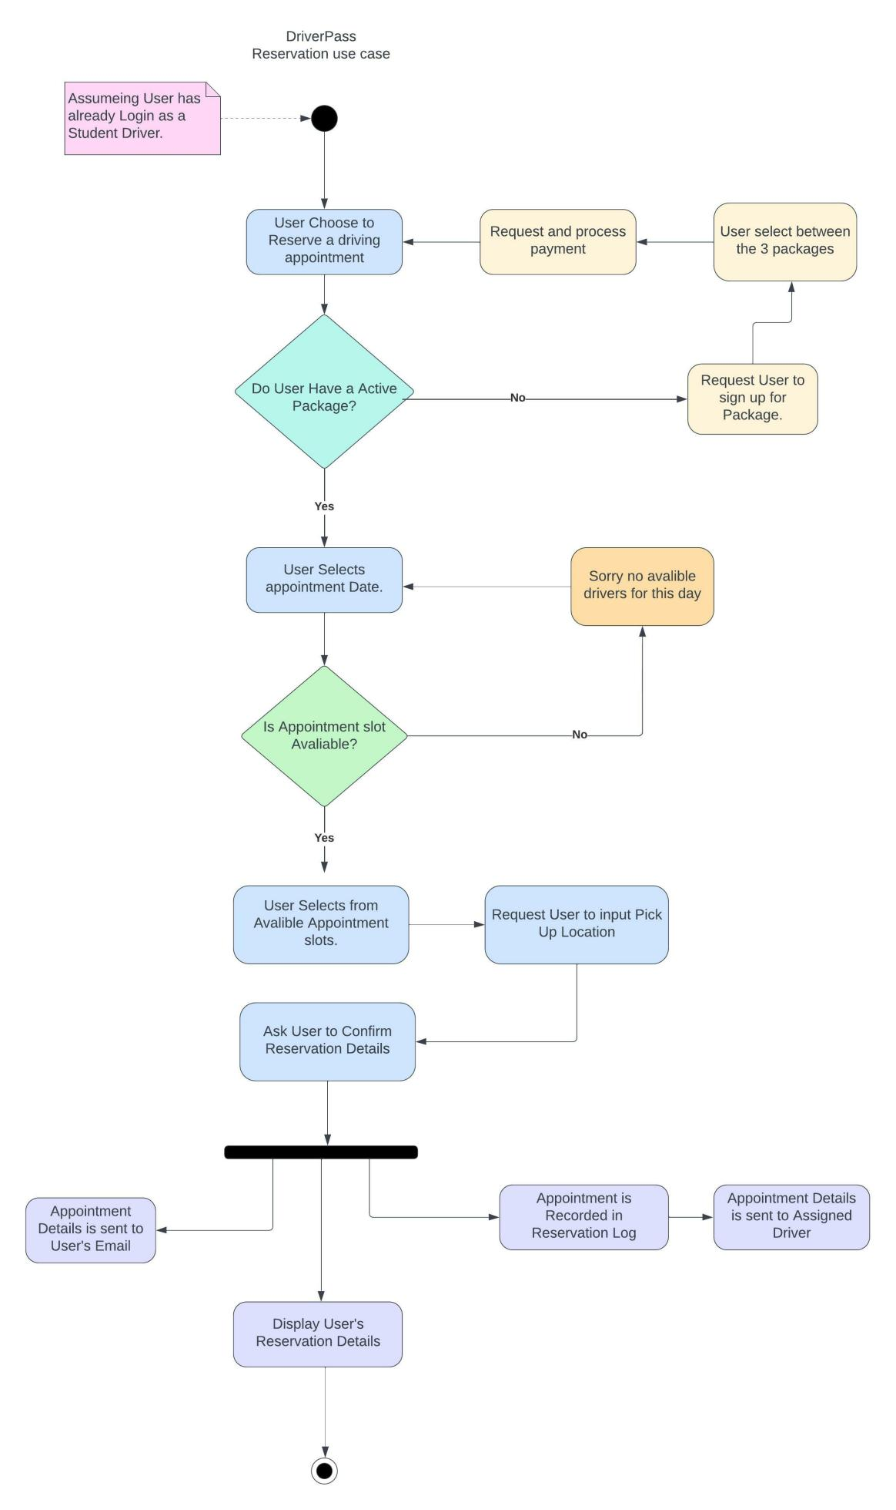

### UML Sequence Diagram

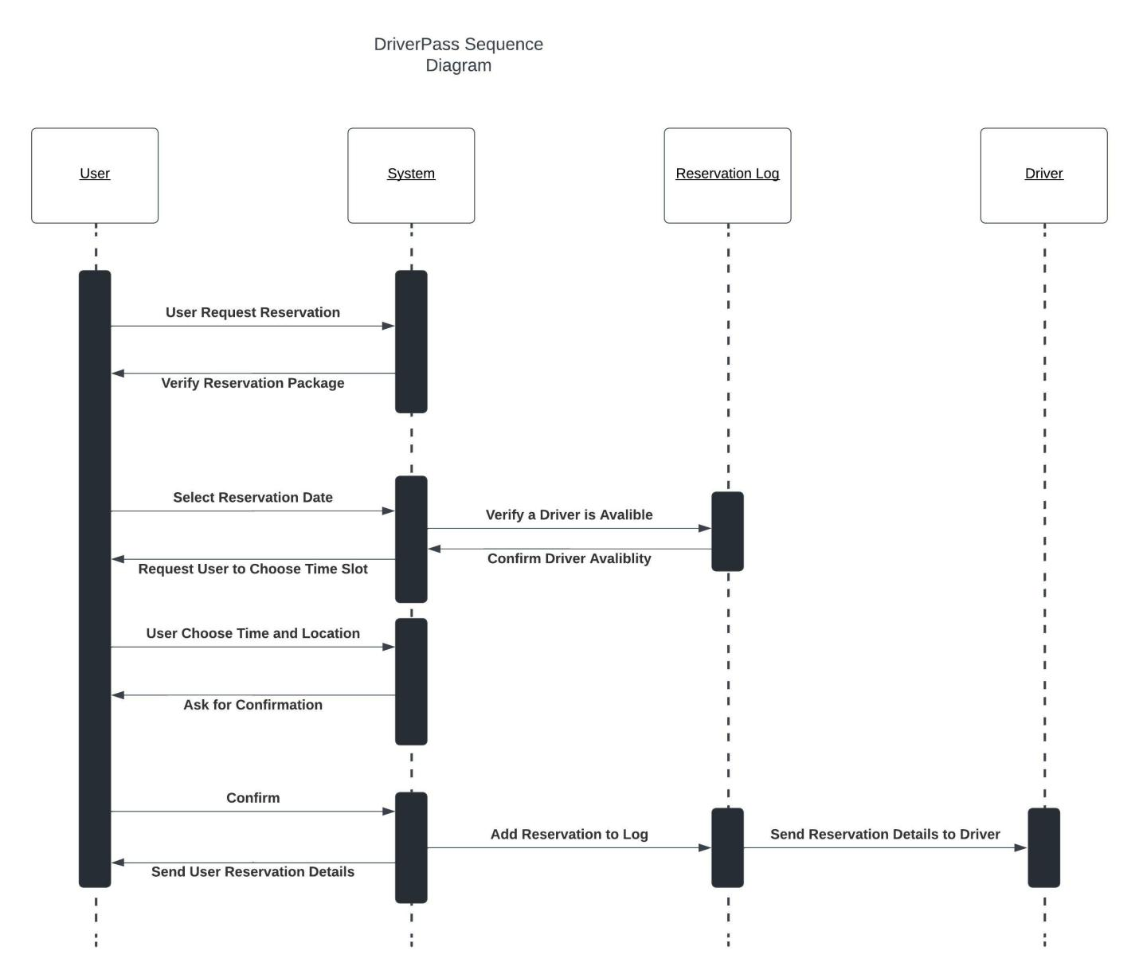

### UML Class Diagram

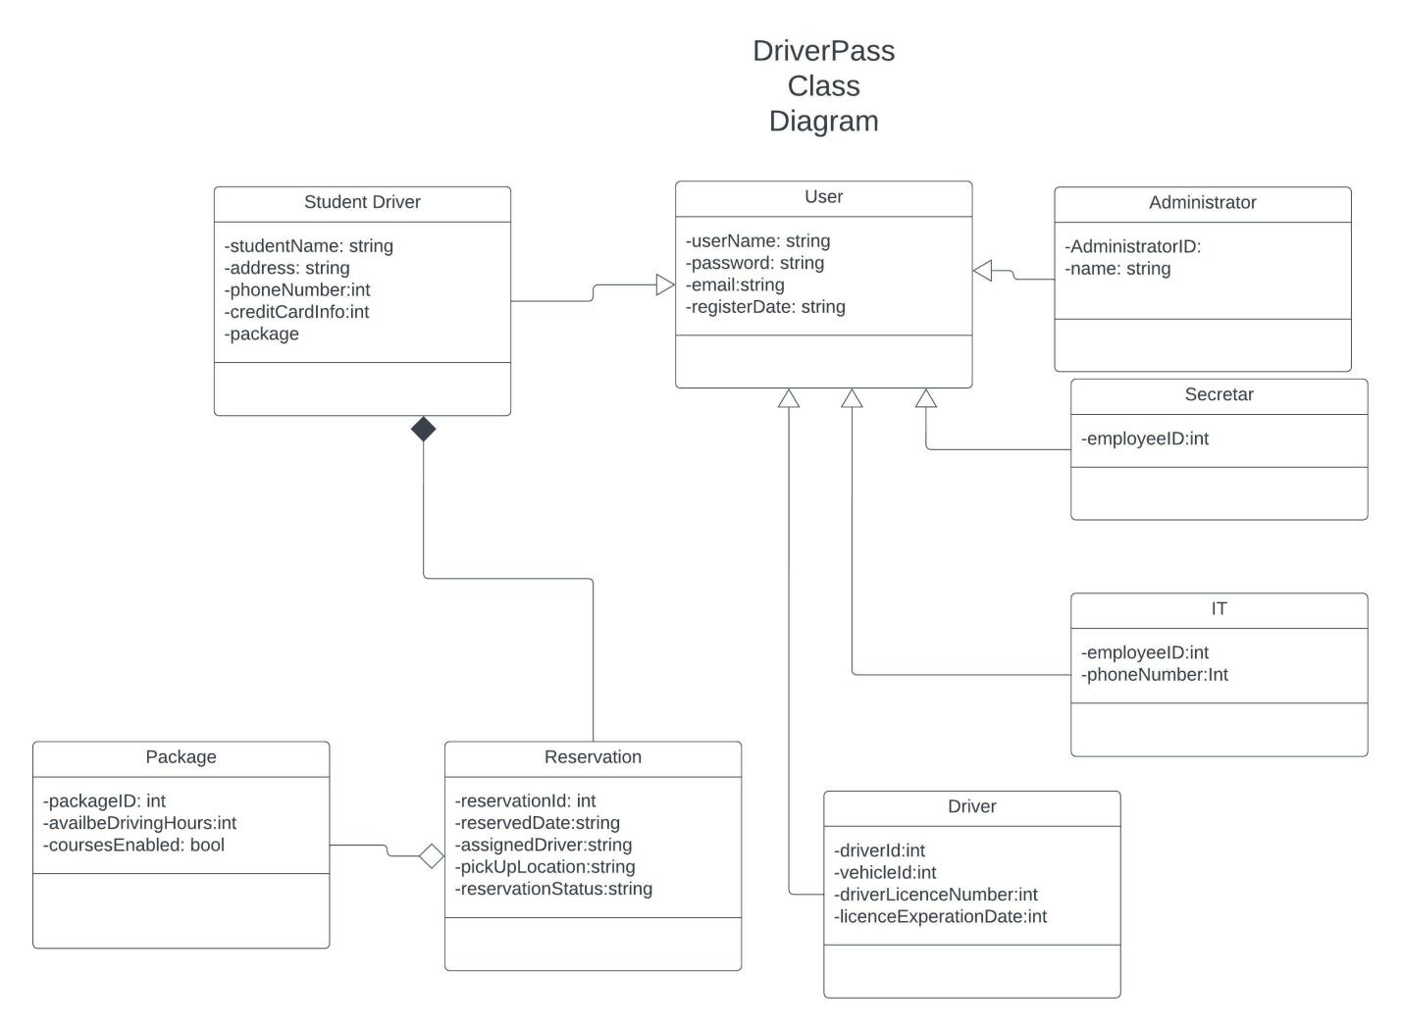

## Technical Requirements

*Because the system is cloud-based the system bypass any hardware, other software or tools to run. The DriverPass System should be able to be access from any computer,phone or tablet with internet access.*